Student #xxxxxxxx
Teacher # xxxxxxxx
School # xxxxxxxx
Size  Media |  | Size  Media |  | Size  Media
Size  Media |  | Size  Media |  | Size  Media
Size  Media |  | Size  Media |  | Size  Media
Size  Media |  | Size  Media |  | Size  Media
Concentration Statement = x# of words or less

Studio Art Digital Submission

Beginning this school year, the College Board will implement a digital, Web-based submission process for the three AP Studio Art portfolios. For the May 2009 exam administration, artworks for Studio Art portfolio sections that have traditionally required slides will now be submitted as digital images.

Please note that changing from slides to digital submission will not change any of the content requirements for the portfolios. The Quality section for the Drawing and 2-D Design portfolios will still require you to submit actual artworks, and the number of images required for all sections will remain the same.
As more information becomes available this fall, this page will be updated to include details such as:
- Your role in the digital submission process
- Digital imaging specifications and tips
- Web browsers and other technical requirements
- How to access the web application
- Dates and deadlines

When important updates are made to this page, your AP Studio Art teacher or AP Coordinator will let you know when to check back.

Studio Art Exams
Beginning this school year, the College Board will implement a digital, Web-based submission process for the three AP Studio Art portfolios. Beginning with the May 2009 exam administration, portfolio sections that have traditionally required slides will now require digital images instead of slides.
Please note that changing from slides to digital submission will not change any of the content requirements for the portfolios. The Quality section for the Drawing and 2-D Design portfolios will still require students to submit actual artworks, and the number of images required for all sections will remain the same.
When updates are posted to this page, the College Board will notify AP Coordinators via email.

Technical requirements
To effectively access the AP Studio Art Digital Submission Web application, users must use the operating systems and browsers listed below. Users are not restricted to specific hardware configurations; however, it should be noted that using older computer hardware may result in slower response times.

Software requirements
Operating system must be one of the following:
- Windows XP (Home or Professional)
- Windows Vista (Home, Business, Premium, or Ultimate)
- Mac OS (10.4 or higher)
Web browser must be one of the following:
- Internet Explorer (6.0 or higher)
- Firefox (2.0 or higher)
- Safari (2.0 or higher)

Requirements for students' digital images
File format: All images must be submitted in JPEG format (file name extension .jpg).
Image size:
- Landscape orientation:
  - Recommended maximum size: 780 × 530 pixels (10.83 × 7.36 inches)
  - Recommended minimum size: 480 × 480 pixels (6.67 × 6.67 inches)
- Portrait orientation:
  - Recommended maximum size: 530 × 780 pixels (7.36 × 10.83 inches)
  - Recommended minimum size: 480 × 480 pixels (6.67 × 6.67 inches)
Note: The image sizes above are recommendations. Your students' image sizes may be different.
Maximum file size: 3.0 MB per image

Free disk space
Drawing portfolio: Based on the maximum file size of 3.0 MB and a total of 24 digital images, each student would need a maximum of 72 MB of free disk space.
2-D Design portfolio: Based on the maximum file size of 3.0 MB and a total of 24 digital images, each student would need a maximum of 72 MB of free disk space.
3-D Design portfolio: Based on the maximum file size of 3.0 MB and a total of 38 digital images, each student would need a maximum of 114 MB of free disk space.

Free Disk Space
- Drawing Portfolio: Based on the maximum file size of 3.0 MB and a total of 24 digital images, each student would need a maximum of 72 MB of free disk space.
- 2-D Design Portfolio: Based on the maximum file size of 3.0 MB and a total of 24 digital images, each student would need a maximum of 72 MB of free disk space.
- 3-D Design Portfolio: Based on the maximum file size of 3.0 MB and a total of 38 digital images, each student would need a maximum of 114 MB of free disk space.
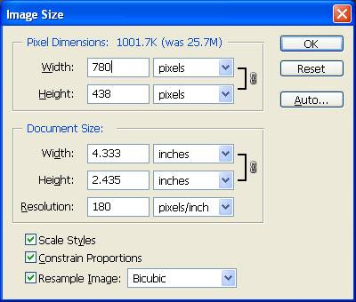
Landscape Max Size = 780 x 530 pixels

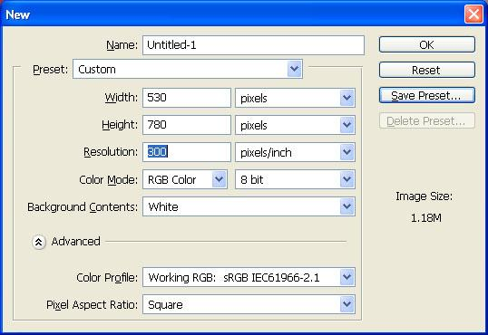
Portrait MAX. Size = 530 x 780 pixels

