History of Ceramics-
Ceramics has been around for centuries. During the _____________ the first ceramics were used for:
- Cooking
- Containers
- Storing _______________
Where were the first ceramics fired?
- ________________________
Information About Clay-
Clay is used to make ceramics. There are different kinds of clay. What kind do we use?
- ___________________ Terra Cotta Clay-Good for Handbuilding
- ___________________ Stoneware Clay –Good for Pottery
Describe the Clay Stages:
- ____________________-clay can be formed without tearing/breaking
- ____________________-clay has dried but can be carved/joined
- Bone Dry-moisture has evaporated and surface is no longer ___________________
- Bisqueware-after 1st __________________________________________________
- ____________________________-after 2nd firing/ready for use functionally or as a decoration
Clay _________________ is DANGEROUS! What can you do to be safe?
- Use wet sponge to clean tables
- Use water to clean tools and sinks
- NEVER use a ______________________ (inhaling dust is harmful)
- NEVER _____________ in room (ingesting is harmful)
Before Working with Clay-
- During this semester, consider cutting your ____________________ shorter than usual.
- Take off your jewelry and put it somewhere safe!
- Same goes for watches.
- Roll up those sleeves!
- Pull your long hair back so it’s not in your way.
- NO food.
- Don’t get your device messy! Clay can ruin it!
- Wear an _____________________! That’s why we have them!
Working with Plastic Clay-
Name the hand building methods.
- ________________-between fingers and thumb
- Coil-roll clay snakes
- Slab-roll thin, flat clay
- Mold-clay takes on certain shape
What kind of wedge do we use?
- ________________ head
Why does standing up help you wedge your clay?
- Use your upper body strength as leverage
Why do we wedge?
- Consistency and eliminates ________________ (which make your project explode/crack in the kiln)
About how thick should your clay be for each project?
- ________________ width or 1/4"
What should you do if your clay is too dry?
- Spray with ________________ bottle
- Smooth cracks with a wet finger
- Cover with damp rag
What should you do if you clay is slumping?
- Expose it to air
How can you keep your clay moist over night?
- Cover with damp rag
- Wrap in air-tight ________________ bag
If it dries too quickly, what can happen to your project?
- Crack
Working with Plastic or Leather Hard clay-
What process is used to join two pieces of clay?
- Score, slip and wiggle. Use a serrated rib and water to score (________________) and slip (add water to) the edges. Then, wiggle them together. Clay must be plastic or leather hard.
How do you recycle clay?
- If it’s too ________________-put clay in the clay bucket. We mix it with water and put it on a plaster slab to dry to the plastic stage again. Wedge before using it.
What are the finishing touches?
- Use a needle tool to write your ________________ and HOUR on the bottom of your piece.
- It must be legible!!!
Getting Clay to the Bone Dry Stage-
- When you’re finished with construction, allow your piece to dry ________________ so it won’t crack!
- Simply move the plastic bag so it’s not covering the bottom of your piece. Gradually, you'll move it to the ________________ of the piece.
- The bigger the project, the ________________ this will take. Humidity in the air will play a factor as well.
The Bisque Firing Process-
What’s the technical term for the shelves and posts used inside the kiln?
- Kiln ________________
What happens to clay when it’s bisque fired?
- Chemical reaction (turns dry and hard)
We bisque fire to cone 04. What temperature is that?
- ________________degrees Fahrenheit
The Glaze and Glaze Firing Process-
Why do we glaze ceramics?
- Waterproof (glaze turns to glass during the firing process)
- Easy to________________
- Aesthetics
There are different kinds of glazes. What do we use?
- Glaze and Underglaze. After firing, you can eat off it, put it in the ________________ or microwave!
Why do we use wax resist on the bottom and ¼ inch up from the bottom edge of our work?
- It will be easier __________________ the bottom and ¼ inch up from the bottom.
- When you’re finished glazing your piece, use a sponge to clean the glaze off the _____________.
- I will NOT fire pieces that haven’t been cleaned because they will become _________________ to the kiln shelf during firing.
Why do we paint kiln wash on the kiln shelves?
- To protect the shelves from dripping glaze.
We glaze fire to cone 05. What temperature is that?
- 1888 degrees Fahrenheit
Label the Vessel:
-___________________
-___________________
-___________________

-___________________

-___________________
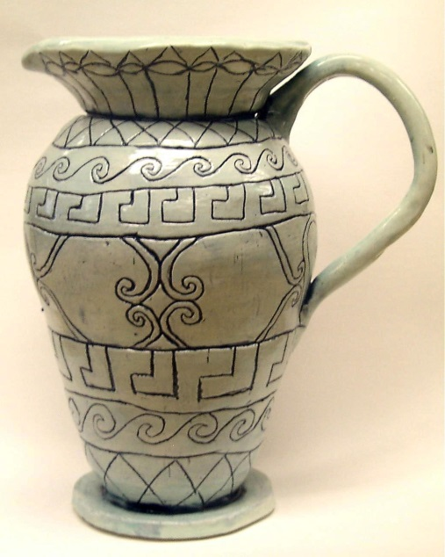
Label the Vessel:
-Lip
-Neck
-Shoulder

-Body

-Foot

