Stamps:
Stamps can be used to create surface texture and patterns in clay. The artist impresses the stamp into the clay leaving the design behind. Stamps may be used over and over again to create a repeating pattern.

Project Progression:
We will make our stamps. Then, fire them. Finally, we’ll use them to create texture in another project.

Plan Your Stamp:
Stamps will be about the size of your thumb. Things to consider:
-Will I carve my design into the tips of the stamp? If so, will my stamp be round or square?
-Will I carve my design along the side of the stamp so it will be rolled onto the clay? If so, will my stamp be a round cylinder or a clay ball (no bigger than a grape!)?

*You will need to have your initials somewhere on the stamp. They can even be part of your design! Just remember, you are making the negative, so they will have to be backward letters. That way, when they are stamped into a project, your letters will be the positive and readable.

Check out the examples below. Then, draw the shape and designs for your stamp:
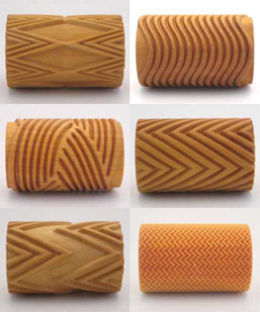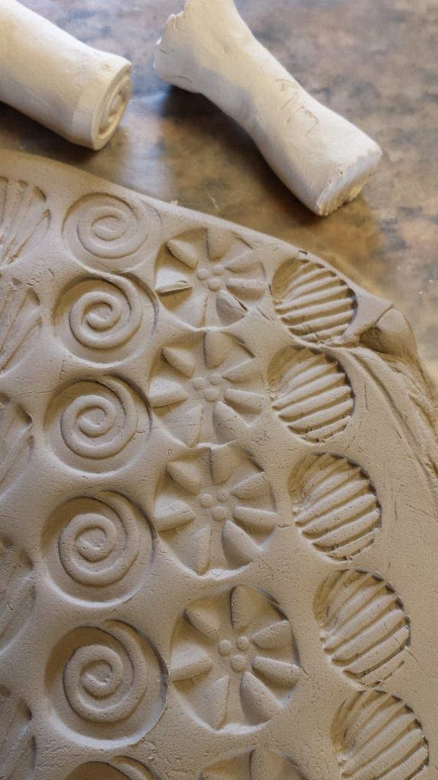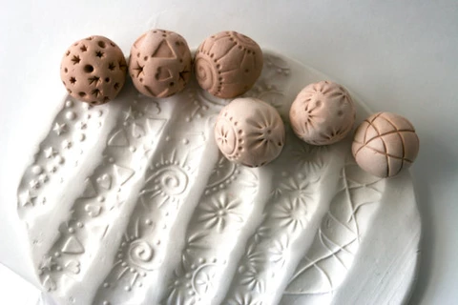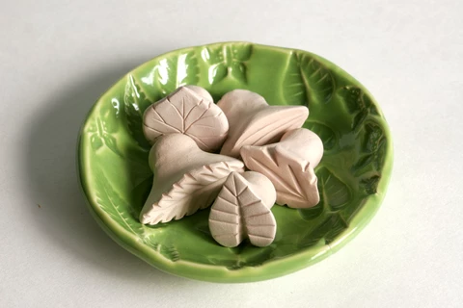
Stamp Rollers Stamps (tips) Stamp Ball Rollers Stamps in a stamp-decorated bowl

My Stamp Shape: My Stamp Design:

