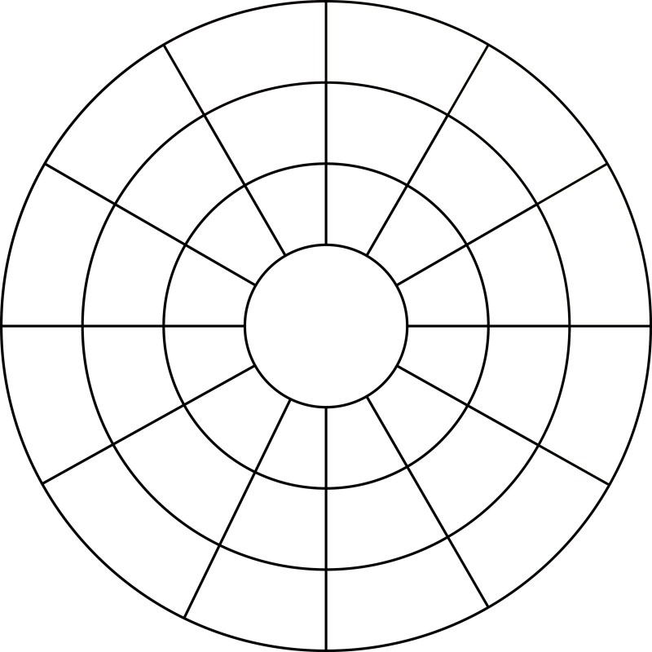
NAME:____________________
DIRECTIONS:
Paint the outside circle sections following the color wheel pattern.
Paint the middle circle sections following the color wheel pattern but adding a white tint.
Paint the inside circle sections following the color wheel pattern but adding a black shade.

