Enlarging an Image Using a Grid
Step 1
Label the boxes on the sides of the grid. I prefer to go A, B, C, etc. on the left and right sides and 1, 2, 3 on the top and bottom. Labeling the boxes makes it much easier when you get into the middle of the grid and you start getting lost.
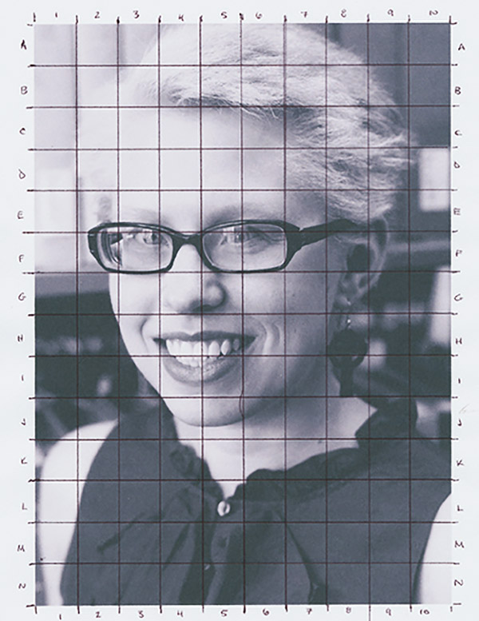

Step 2
Determine the final size of your drawing. We are doubling the size to enlarge our drawings. Here you'll have to do some calculations.
*Remember that many rulers do not start measuring at the end of the ruler, but rather in a ways! Be mindful of this!
Measure your picture: Across __________”
Down ___________”
Now multiply by 2: Across ________ x 2 = _______________”
Down ________x 2 = _______________”
Your final drawing will be: Across _____________”
Down _____________”
Measure and draw out the outer rectangle/square of your final drawing. Remember to draw very lightly!

Step 3
Draw out your final grid on your drawing paper. Draw lightly because we will be erasing the grid when we are finished!
Label your new grid identical to the smaller grid on the photograph.

Step 4
Begin drawing. Pick where to start. I like to start at a recognizable point. Perhaps it's the bottom of a chin or the part in someone's hair. Here I'm starting at the bottom left of the chin.
Look at the box that contains your starting point and find the corresponding box on the bigger paper. For me, that's box J4. Copy the outline line in that box. I drew in the curve of the chin in box J4.
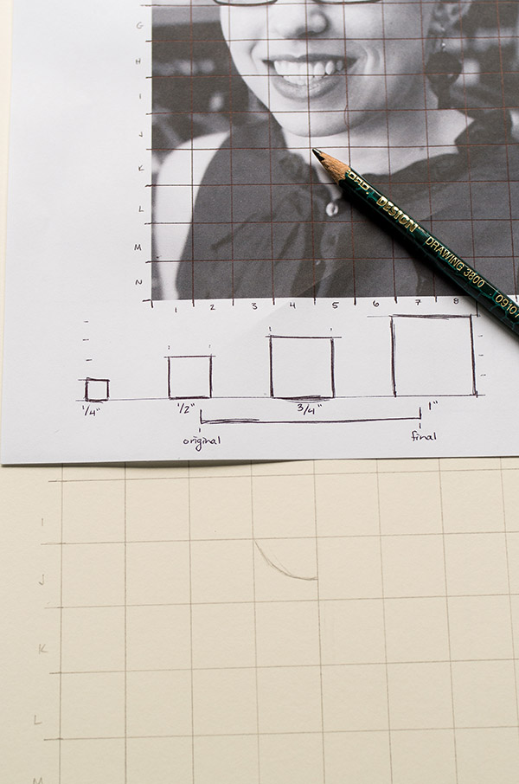

Step 5
Follow the outline from box to box, using the grid labels to help you know where you are. I usually work left to right and slowly make my way around the head first. A good tip is to look at where the outline starts and ends in each box. Is it touching the middle of the outer grid box line or the corner? It becomes a bit more mathematical when you do it this way but you won't get lost and you'll be closer to the actual image.

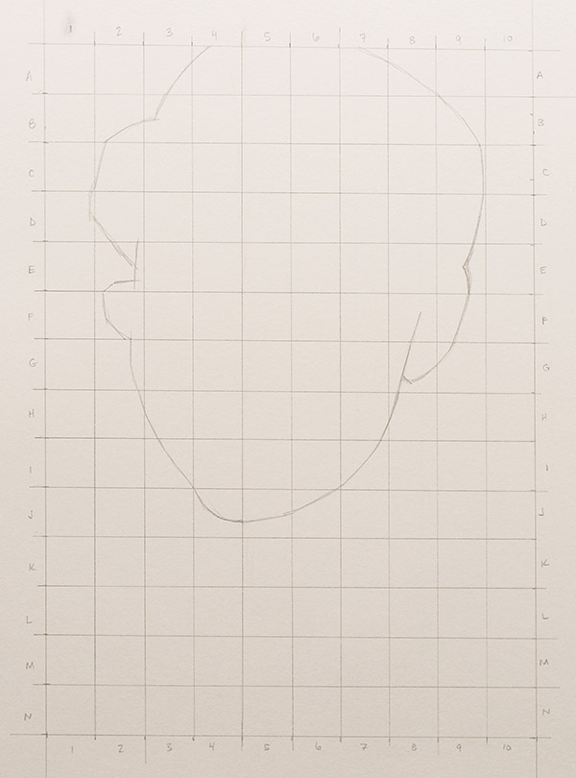

Continue drawing until you have all of the big shapes penciled in. If your lines don't meet up in the end, go back to the labels on the boxes and double-check yourself box by box. By big shapes I mean the outlines of the people or landscape or animal that you're drawing.

Step 6
Begin adding the details. Now that you have all the big shapes drawn in, begin to pencil in the smaller details like hair lines, eyes, ears, etc.
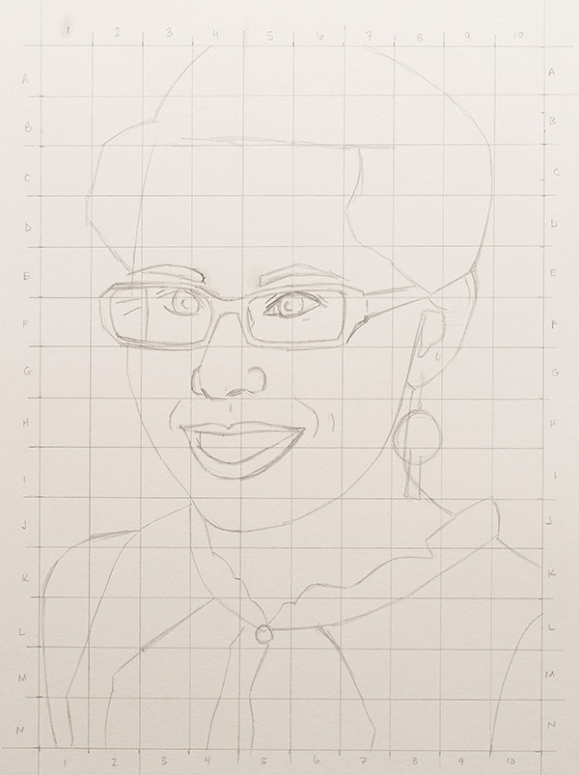

Keep looking at the grid labels to check that you're making the details in the right boxes. Generally if you're going to get lost, you'll do it here.

Step 7
Now that your drawing is finished, check over the drawing box by box. This is the boring part but you want to catch any mistakes now and not once you start painting or inking.
Step 8
Erase the Grid and Start Adding Value

