Our goal by the end of class is to have a high contrast image of you for your self-portrait. It needs to be black and white (no gray!). It needs to be printed and needs to take up the full page. 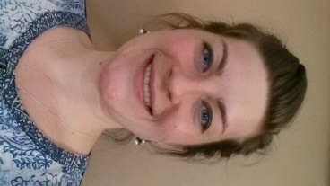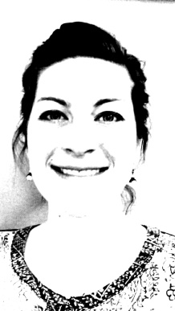
Photoshop-one way:
- Go to Adobe Photoshop and open student picture.
- Go to Image (In the toolbar at the top of the page), click on Image size and change the size to 8 inches by 10 inches.
- Click again on Image, go to Mode and change photo to Grayscale. Click OK to discard color information.
- Click Image again, go to Adjustments, and scroll to Brightness and Contrast. Change the Brightness and Contrast by moving the arrow to the right. Usually, the brighter and more contrast, the better. Click OK.
- Go to Image again, scroll to Adjustments and scroll down to Posterize. Change level to a 2 or 3. You want a solid black/white image. If there is gray, you can undo and go back and add more brightness or contrast so that more areas will appear black/white when you posterize.
- Check with me before you print your digital image.

Photoshop-a second way:
- Go to Adobe Photoshop and open student picture.
- Go to Image (In the toolbar at the top of the page), click on Image size and change the size to 8 inches by 10 inches.
- Go to Image, Adjustments and Thresholds. Hold down the arrow and move left and right for high contrast, but not so much that it’s disappearing.
- Check with me and print your digital image.

Smartphone:
- Take your photo.
- Select edit.
- Change color to grayscale.
- Increase exposure.
- Increase contrast, but not so much that it’s disappearing.
- Check with me.
- Email your image to yourself.
- Print a full page image.

